

Best Practices

Concierge Assistant

Rental and Inventory Items

The Rental and Inventory Items feature of The Concierge Assistant tracks the items you rent, lend, sell or give to guests. It will also notify you when the “returnable” items are due back and your supply of “‘inventory” items are running low.

The Rental and Inventory Items feature of The Concierge Assistant has recently undergone an extensive makeover. The newer version has been improved to include Hourly as well as Daily Returnable Items and Inventory Items are now under a separate tab making it easier to track those items that are sold or given to the guest and require inventory controls for reordering when supplies go below the “Par level” indicated for each category. The screen has been reformatted to include its more extensive abilities.

(Before using this feature, be sure to set up the Default Values under the tab labeled “Set Default Values”. Please refer to the discussion on this topic at the end of this document.)

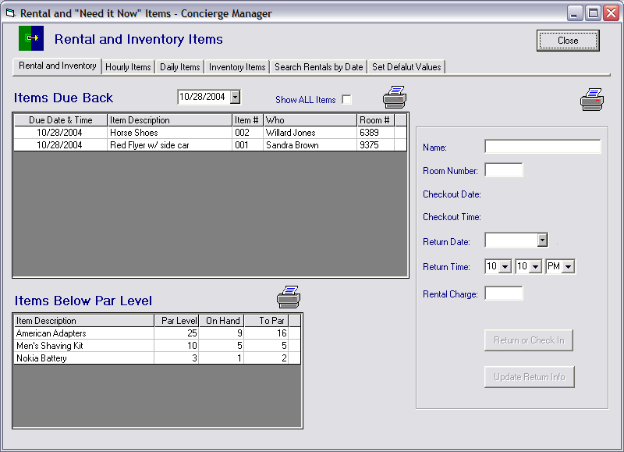

The opening screen, “Rental and Inventory”, provides you with a daily listing of the “Items Due Back” for the current calendar day, with the option to select any date you wish. You may also choose to “Show All Items” outstanding by placing a checkmark in the box.

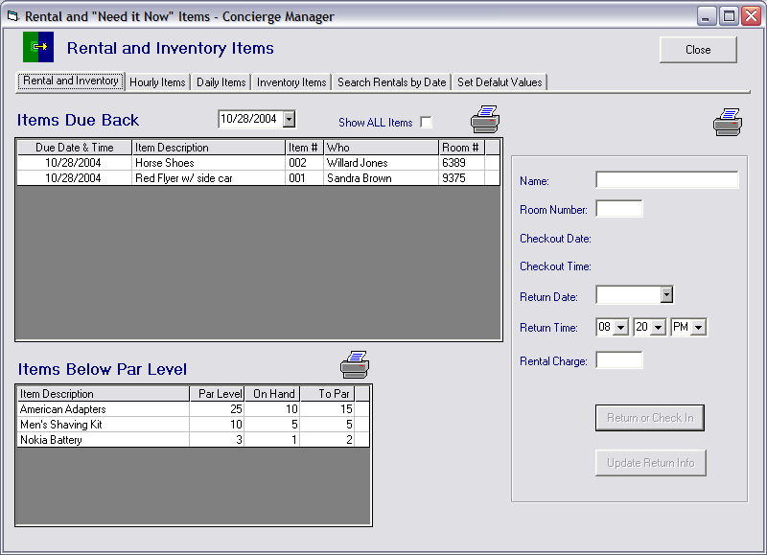

To update the returnable item’s information, double click on the item in the display area. The rental information will be displayed in the boxes to the right. You may then choose to either “Return or Check In” the item or extend the Return Date, the Return Time, the Rental Charge (if applicable) and click on the “Update the Return Info” button.
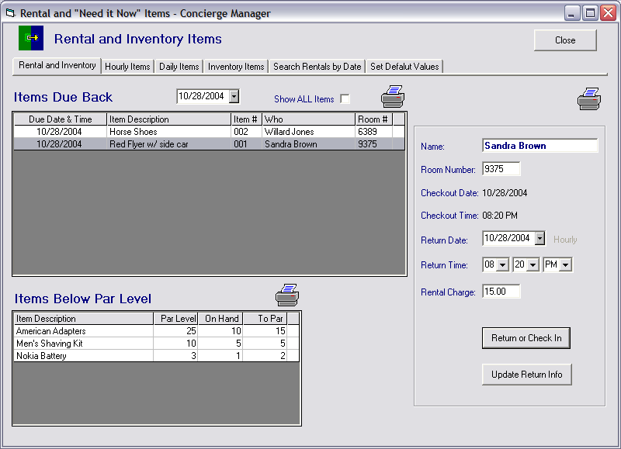

The system will automatically print out a receipt ready for the guest’s signature whenever the item is Checked In and/or Checked Out, (Please refer to the section on “Set Default Values”), You may also manually request this same form whenever you wish, just click on the printer in the top right-hand corner.

The receipt will look like this, ready for the guests’ signature.

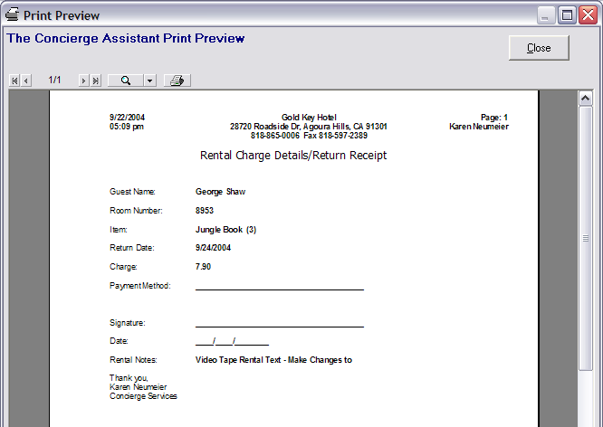

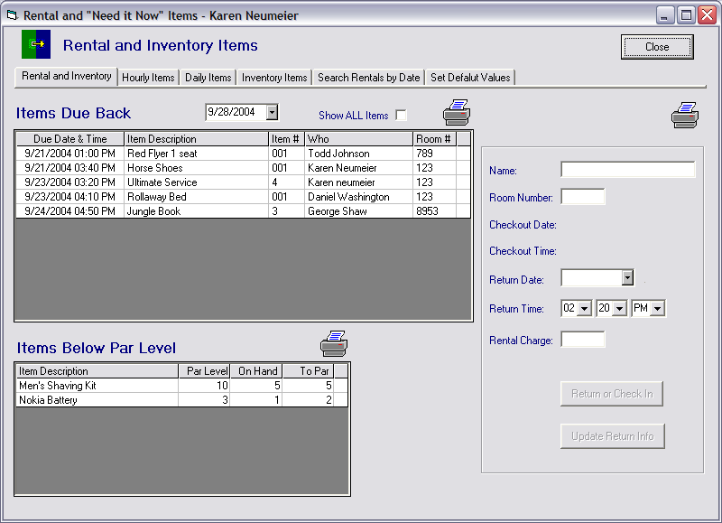

The “Rental and Inventory” screen also displays the “Inventory” items that need restocking. Clicking on the printer icon will provide you with a shopping list of those inventory items that are below “Par”.

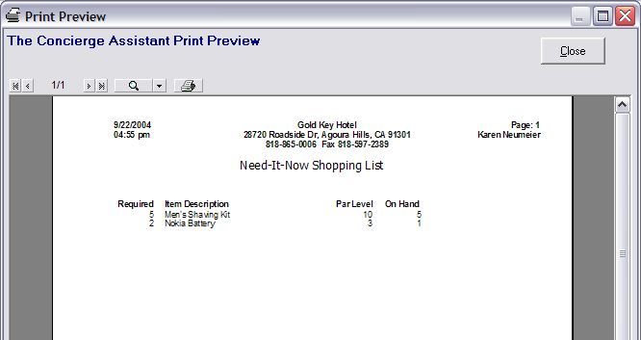

Returnable Items - Returnable Items are the items you expect to be returned (Hourly and Daily Rentals) and are entered individually (e.g. one record for each copy of a DVD).

Hourly and Daily Items: The Concierge Assistant now provides the ability to track ‘Hourly’ as well as “Daily” returnable items. The process is the same for both. Begin by clicking on the tab labeled Hourly or Daily Items.

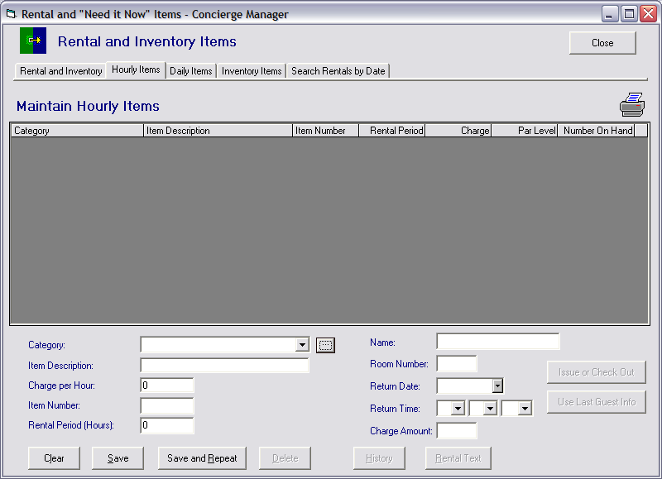

You will first need to establish the categories of the types of hourly and daily rental items that you will have, such as Bicycles, Sporting Goods, Rollaway Beds, Microwaves, Mini-Fridges, DVDs and so on. To do this you will need to click on the little square button to the immediate right of the Category label.

You will get a screen that looks like this.

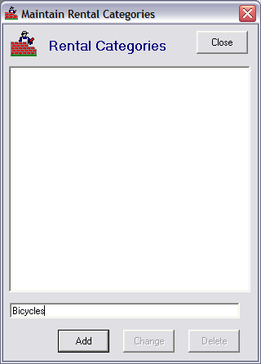
Type in the category of the hourly rental items you wish to track in the narrow white space along the bottom of the box, then click on the “Add” button or press your “Enter” key.
You will only need to do this one time for each category.

When all of the categories have been entered, press the “Close” button. This will return you to the previous screen.

Once you have established your Categories, you may wish to provide the guest with a rental text, which provides information about late returns, damaged property, liability disclaimers, etc.

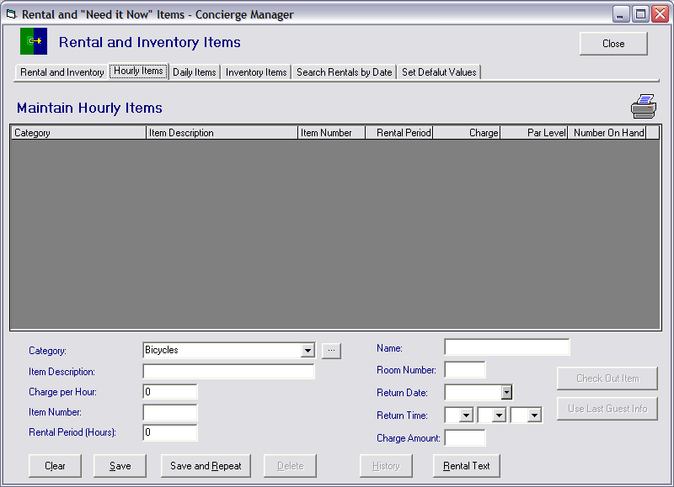

To establish this text you will need to click on the drop down for “Category” and select the category you wish to enter the rental text for. Then click on the “Rental Text” button.

The following screen will appear,

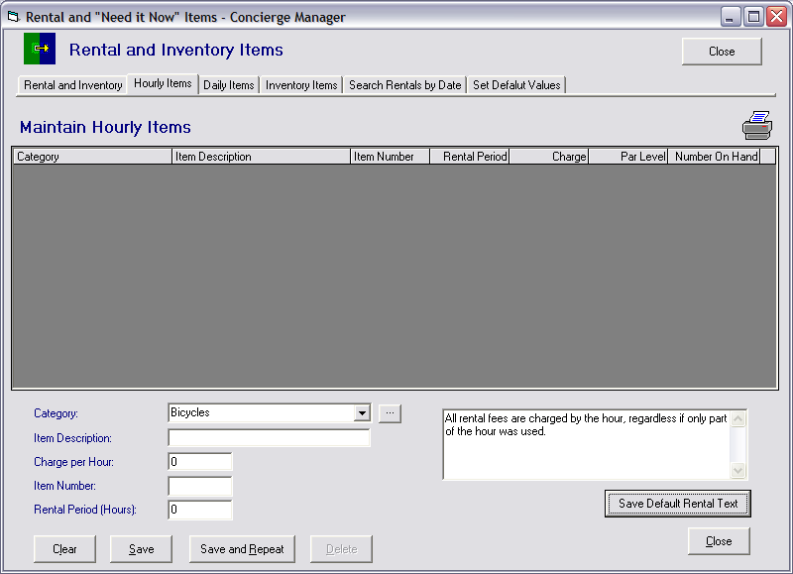

Type in the Rental Text you will need for that category and click on the “Save Default Rental Text” button. Do this for each category established, as desired
Now you are ready to start setting up your Returnable Hourly and Daily Items. You may select your category by using the drop down and highlighting the “Category” of the item you will establish.
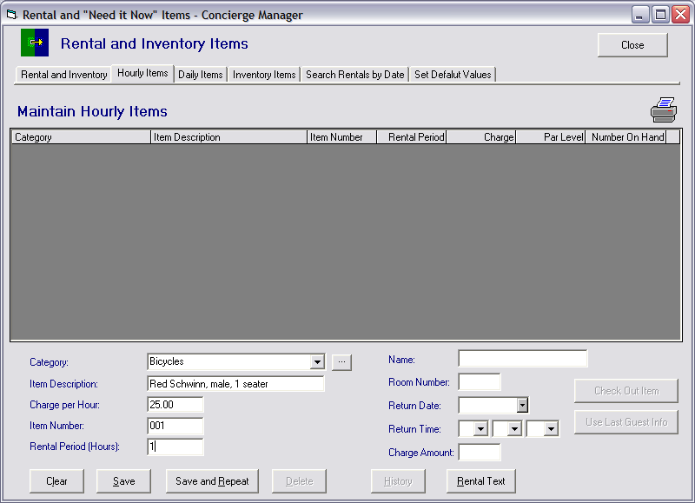

Tab down to “Item Description” and enter the description of item to be tracked; tab and fill in the space marked “Charge per Hour”(if applicable), tab again and fill in the “Item Number” (if an actual inventory number exists, use it), and then tab and fill in the “Rental Period” with a number. Now click on the “Save” button. If you are entering numerous of the same type of item, you will want to use the “Save and Repeat” button as this will save time and extra steps for each item entered.

As you enter the items your screen will begin to look like this:
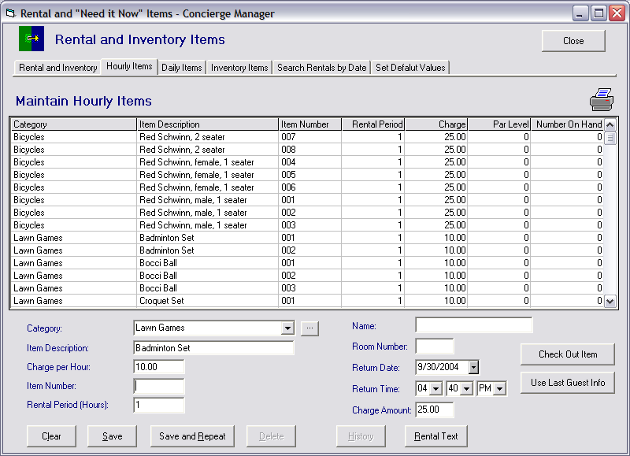
Now you’re ready to start checking out items to the guests. Double-click on the item that will be rented out. This process is the same for both Hourly and Daily Items.

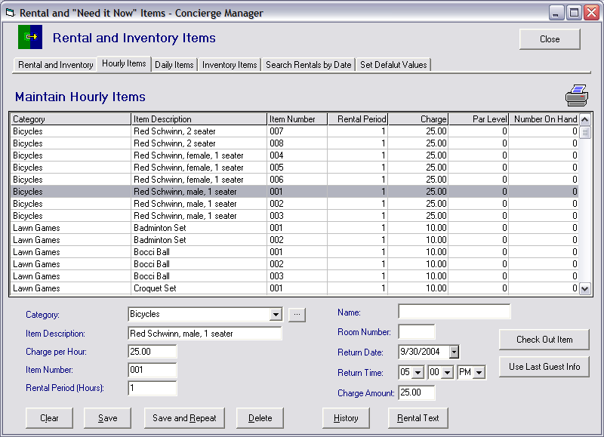

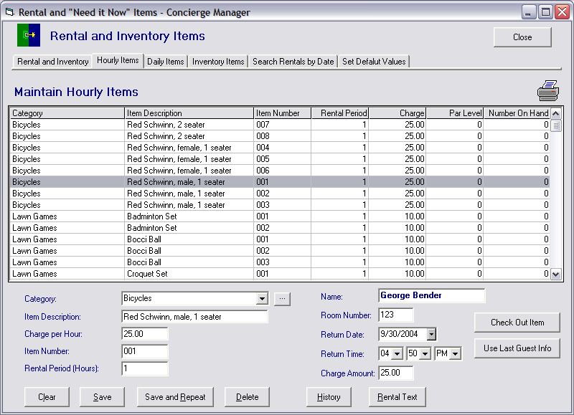

The item’s information will appear on the left. Fill out the information on the right side of the screen with the Guest’s Name, Room Number, Return Date, Return Time and the amount that will be charged for this rental, if any. Then click on the button “Check Out Item”. If you are checking out more than one item to the same guest, click on the button labeled “Use Last Guest Info” to avoid having to type this information again.

The item will turn red to indicate that it is in use and unavailable. You may click on any “red” item to see the name of the person it is checked out to and when it is due back.

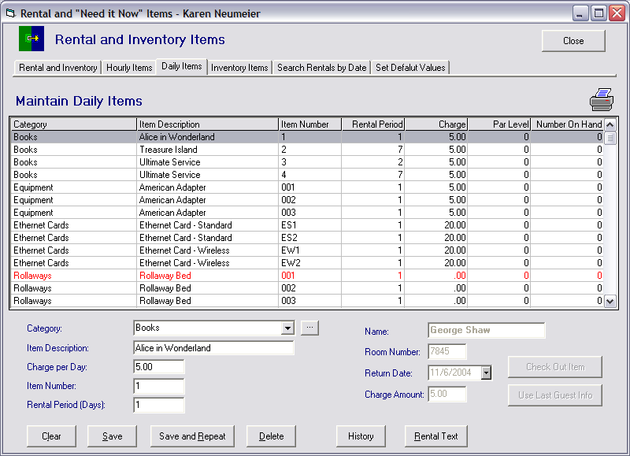

You may also view the history of the item by clicking on the “History” button.

This screen will appear giving you the past rental information on this item.

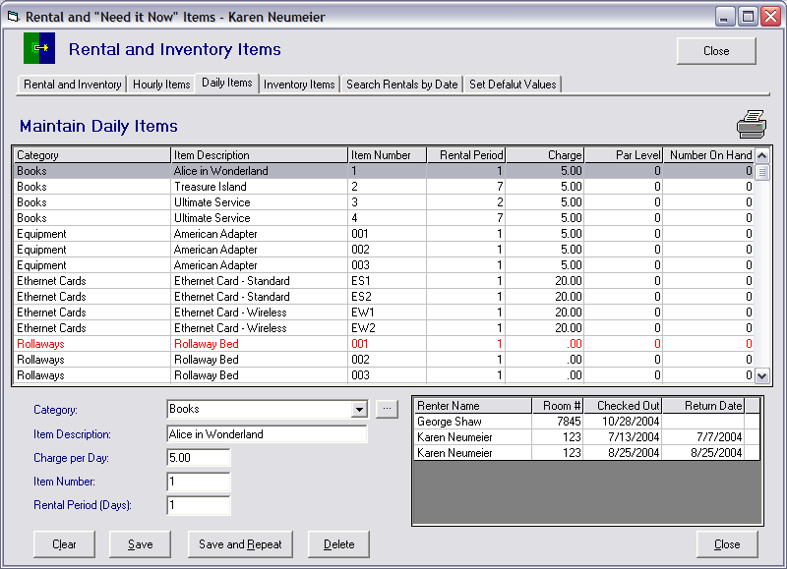

For a complete listing of all of the items under this tab, double-click on the printer and you will get list like the following.

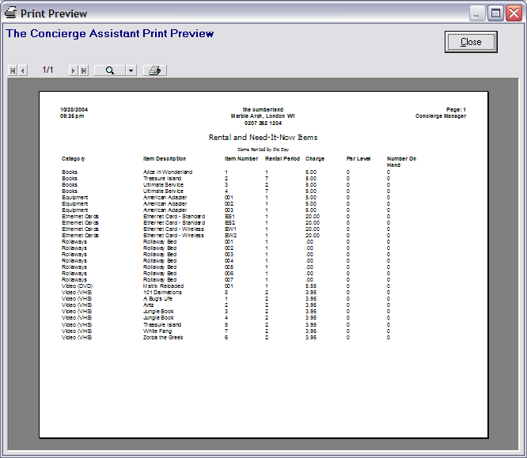

The items that are checked out will appear on the tab labeled “Rental and Inventory” when they are due for return. You may see all items outstanding whenever needed by putting a check mark in the box labeled “Show All Items” (Refer to the section on “Rental and Inventory”).

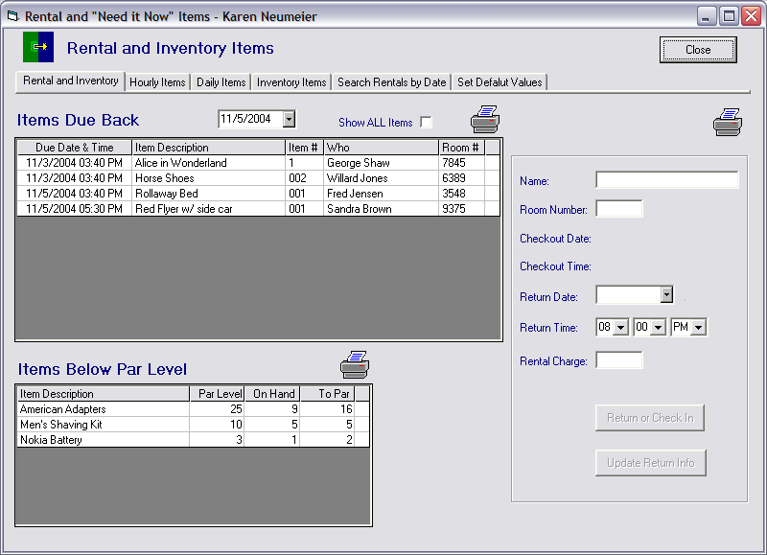

Inventory Items - Inventory items are those items that are sold or given to guests with stock that must be replenished in order to ensure that they are on hand for the next emergency. They are entered once with a quantity on-hand and a par level (e.g. one record for AA Batteries with 20 on-hand and a par level of 10).

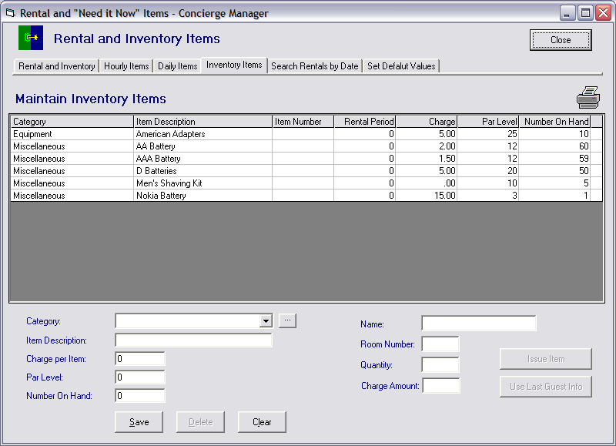

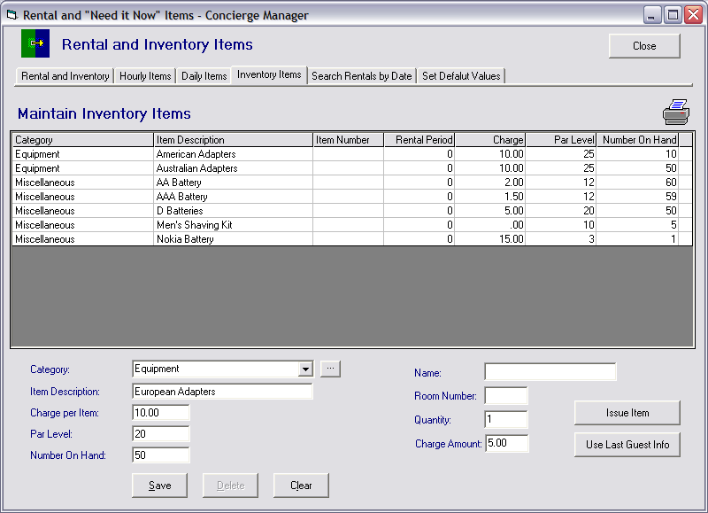

To establish your “Inventory”, select the Category of the items to be entered (to establish a new category follow the same procedure described for the Hourly and Daily Items).
Tab down and enter the Item Description, tab again and enter the amount to be charged for the item (0.00 may be entered). On the next line you will provide a number for the “Par Level” or the number at which you will need to reorder to avoid completely running out. Tab to the next line and fill in the number you currently have on hand.

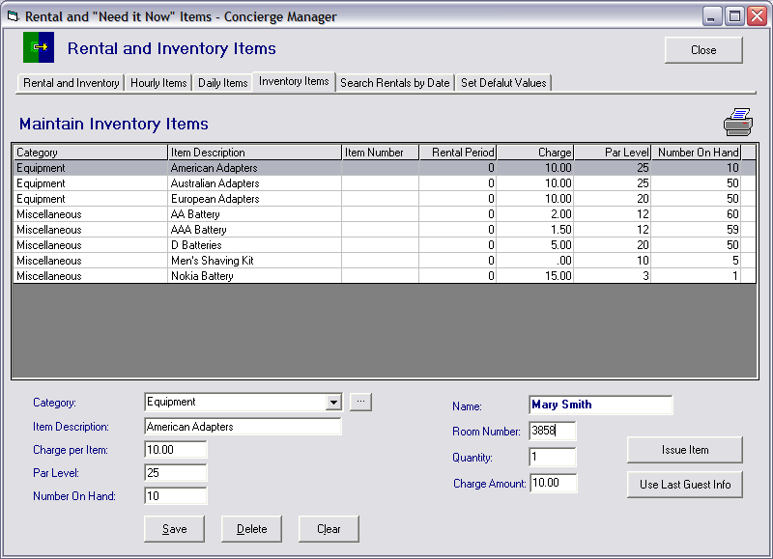

When you issue an inventory item, the system will subtract from your total on hand until it reaches zero (0). When the number on hand goes below the “Par Level” you have established, the item will appear in the first screen on the lower right-hand section under the “Items Below Par Level”. (Refer to the Rental and Inventory section)

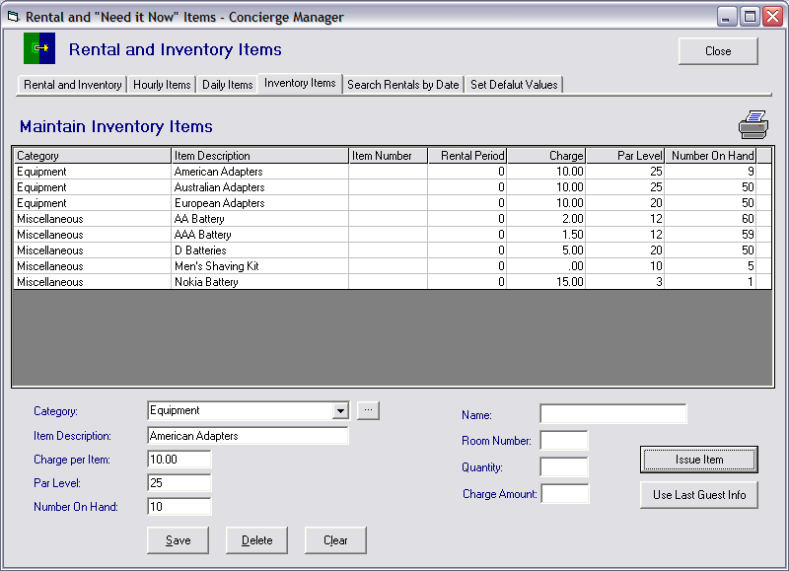

Search Rentals By Date: This latest enhancement gives you the ability to search returned rented items by either their “Returned Date” or their “Checkout Date”. You may narrow down the search by selecting the specific “Category” of the item you are attempting to locate. This feature is very useful when it is necessary to rely on outside vendors for specific types of medical equipment, or children and baby needs as an example. You can create and print reports for each company and their property.
.
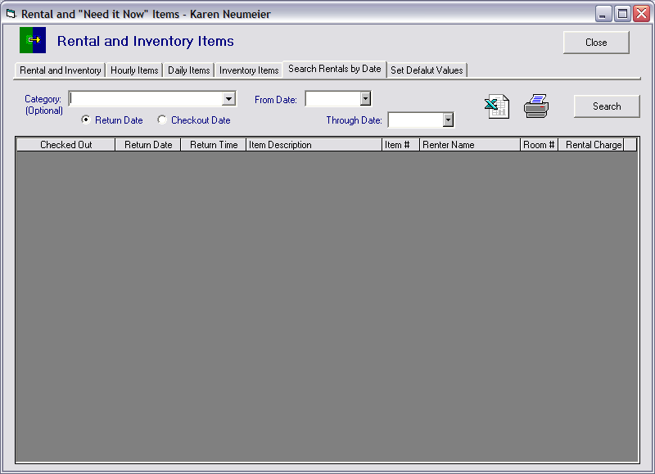

The last tab labeled Set Default Values will be one of the first things you will need to do prior to using the Rental and Inventory Items feature of The Concierge Assistant.

Click on the last tab marked “Set Default Values”

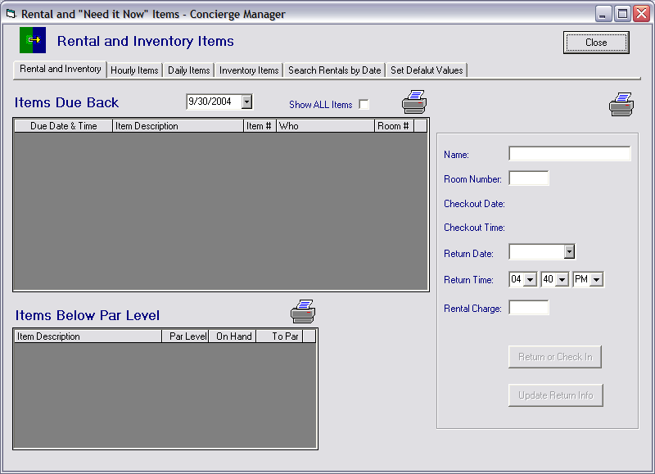

The following screen will appear

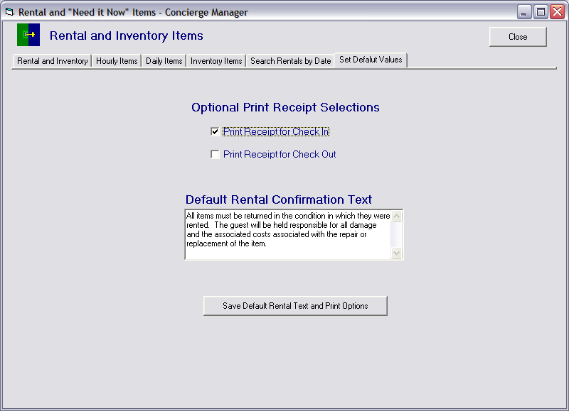

Under the “Optional Print Receipts Selection”, check the box of the option that you prefer, “Print Receipt for Check In” or “Print Receipt for Check Out”. You may select either or both and the system will generate a notice for the guest’s signature. You may also manually generate a notice by clicking on the printer on the tab marked “Rental and Inventory” in the upper right hand corner, after clicking on the item being checked out or updated.

As an option you may create a “Default Rental Confirmation Text” to cover any rental item policies such as late returns, loss or damage, etc. This text will apply to any “Category” not covered by it’s own specific Confirmation Text provided at the Category level. This text may be changed at any time.

Be sure to click on the “Save Default Rental Text and Print Options” button before clicking on any of the other tabs.

